Batch: C3 Roll No.: 16010123217

Experiment / assignment / tutorial No. 7
Grade: AA / AB / BB / BC / CC / CD /DD
Signature of the Staff In-charge with date

Title: Indexing - Create Index and observe the evaluation statistics of
query execution with and without Index

Objective: Implement indexing to improve query execution plans

Expected Outcome of Experiment:
CO 4: Analyse Advanced Database Concepts like indexing, hashing, query processing, query optimization, normalization.

Books/ Journals/ Websites referred:

1. Dr. P.S. Deshpande, SQL and PL/SQL for Oracle 10g.Black book, Dreamtech Press
2. www.db-book.com
3. Korth, Slberchatz, Sudarshan : “Database Systems Concept”, 5th Edition , McGraw
Hill
4. Elmasri and Navathe,”Fundamentals of database Systems”, 4th Edition,PEARSON
Education.

Resources used: PostgreSQL

Theory:

A database index is a data structure that improves the speed of operations in a table. Indexes can be created using one or more columns, providing the basis for both rapid random lookups and efficient ordering of access to records.

While creating index, it should be taken into consideration which all columns will be used to make SQL queries and create one or more indexes on those columns.
To add an index for a column or a set of columns, you use the CREATE INDEX statement as follows:
CREATE INDEX index_name ON table_name (column_list)

Query life cycle

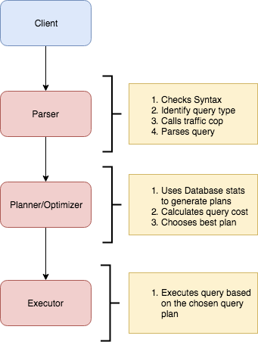

Planner and Executor:
The planner receives a query tree from the rewriter and generates a (query) plan tree that can be processed by the executor most effectively.
The planner in Database is based on pure cost-based optimization -

EXPLAIN command:
This command displays the execution plan that the PostgreSQL/MySQL planner generates for the supplied statement. The execution plan shows how the table(s) referenced by the statement will be scanned — by plain sequential scan, index scan, etc. — and if multiple tables are referenced, what join algorithms will be used to bring together the required rows from each input table.
As in the other RDBMS, the EXPLAIN command in Database displays the plan tree itself. A specific example is shown below:-

Database: testdb=#
- EXPLAIN SELECT * FROM tbl_a WHERE id < 300 ORDER BY data;
- QUERY PLAN
- ---------------------------------------------------------------
- Sort (cost=182.34..183.09 rows=300 width=8)
- Sort Key: data
- -> Seq Scan on tbl_a (cost=0.00..170.00 rows=300 width=8)
- Filter: (id < 300)
- (4 rows)

A simple plan tree and the relationship between the plan tree and the result of the EXPLAIN command in PostgreSQL.
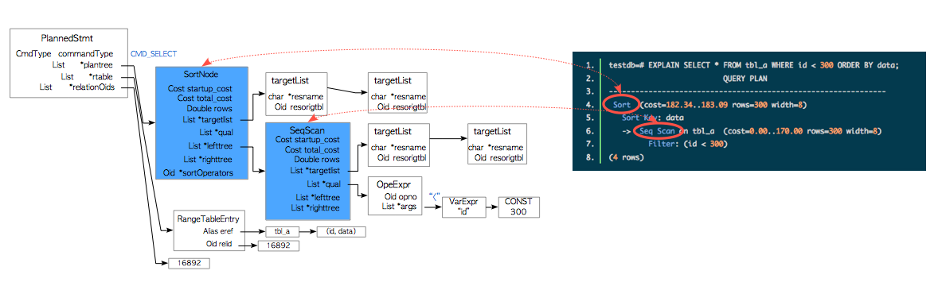

Nodes
The first thing to understand is that each indented block with a preceeding “->” (along with the top line) is called a node. A node is a logical unit of work (a “step” if you will) with an associated cost and execution time. The costs and times presented at each node are cumulative and roll up all child nodes.

Cost:
It is not the time but a concept designed to estimate the cost of an operation. The first number is start-up cost (cost to retrieve first record) and the second number is the cost incurred to process entire node (total cost from start to finish).
Cost is a combination of 5 work components used to estimate the work required: sequential fetch, non-sequential (random) fetch, processing of row, processing operator (function), and processing index entry.

Rows are the approximate number of rows returned when a specified operation is performed.
(In the case of select with where clause rows returned is
Rows = cardinality of relation * selectivity )
Width is an average size of one row in bytes.

Explain Analyze command:
The EXPLAIN ANALYZE option causes the statement to be actually executed, not only planned. Then actual run time statistics are added to the display, including the total elapsed time expended within each plan node (in milliseconds) and the total number of rows it actually returned. This is useful for seeing whether the planner's estimates are close to reality.
Ex: EXPLAIN (ANALYZE) SELECT * FROM foo;
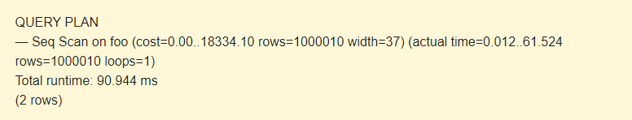
The command displays the following additional parameters:
- actual time is the actual time in milliseconds spent to get the first row and all rows, respectively.
- rows is the actual number of rows received with Seq Scan.
- loops is the number of times the Seq Scan operation had to be performed.
- Total runtime is the total time of query execution.
Query plans for select with where clause can be sequential scan, Index Scan, Index only Scan, Bitmap Index Scan etc.
Query plans for joins are Nested loop join, Hash join, Merge join etc.

Indexing: CREATE INDEX constructs an index on the specified column(s) of the specified relation, which can be a table or a materialized view. Indexes are primarily used to enhance database performance (though inappropriate use can result in slower performance).
Syntax
CREATE [ UNIQUE ] INDEX [ CONCURRENTLY ] [ [ IF NOT EXISTS ] name ] ON [ ONLY ] table_name [ USING method ]
( { column_name | ( expression ) } [ COLLATE collation ] [ opclass [ ( opclass_parameter = value [, ... ] ) ] ] [ ASC | DESC ] [ NULLS { FIRST | LAST } ] [, ...] )
[ INCLUDE ( column_name [, ...] ) ]
[ NULLS [ NOT ] DISTINCT ]
[ WITH ( storage_parameter [= value] [, ... ] ) ]
[ TABLESPACE tablespace_name ]
[ WHERE predicate ]

example
explain Analyse select * from std2 where branch ='ext'
create index dept on std2(Branch)
select * from std2
explain Analyse select * from std2 where branch ='ext'
drop index dept

Implementation Screenshots :
Comprehend how indexes improves the performance of query applied for your database . Demonstrate for the following types of query on your database
  - Simple select query
  - Select query with where clause
  - Select query with order by query
  - Select query with JOIN
  - Select query with aggregation
A)
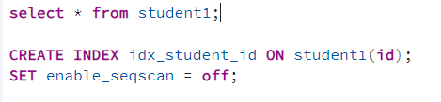

B)
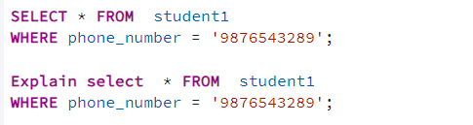
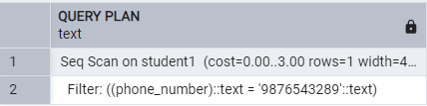
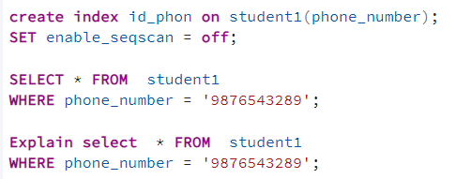
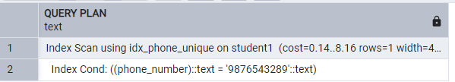

C)
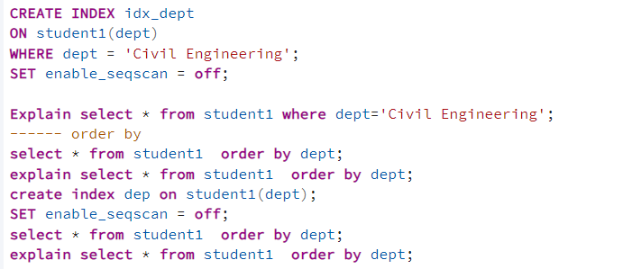
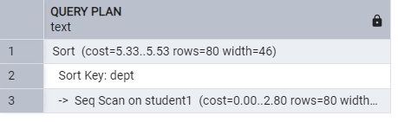
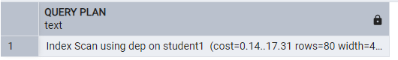

D)
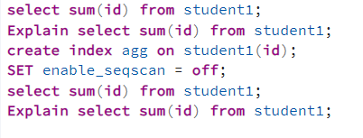
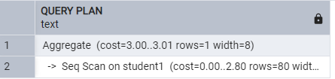
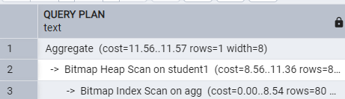

E)
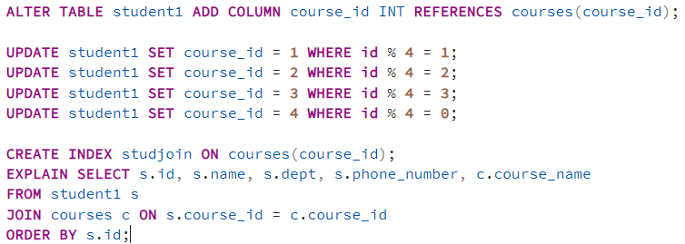
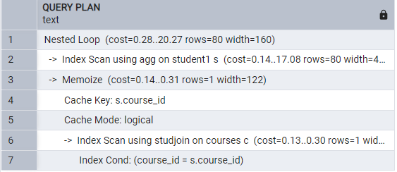

Post Lab Question:

- How does a B-tree differ from a B+-tree?
Ans.
• Data Storage
- B-tree: Data in both internal and leaf nodes.
- B+-tree: Data only in leaf nodes; internal nodes store keys.
• Leaf Node Connection
- B-tree: Leaf nodes are not linked.
- B+-tree: Leaf nodes are linked for efficient sequential access.
• Search Efficiency
- B-tree: Slower as data is spread across nodes.
- B+-tree: Faster since all data is in sorted, linked leaf nodes.
• Insertion & Deletion
- B-tree: More complex due to balancing requirements.
- B+-tree: Simpler as changes mainly affect leaf nodes.
• Duplicate Keys
- B-tree: No duplicate keys.
- B+-tree: Allows duplicates, useful in some applications.
• Structure Height
- B-tree: More levels, lower fanout.
- B+-tree: Fewer levels, higher fanout.
• Use Case
- B-tree: General-purpose balanced search tree.
- B+-tree: Ideal for databases and file systems with range queries.
- Why is a B+-tree usually preferred as an access structure to a data file?
Ans.
- Efficient Disk Access – Internal nodes store only keys, increasing fanout and reducing tree height, minimizing disk reads.
- Sequential Access – Leaf nodes are linked, enabling fast range queries.
- Consistent Search Performance – Uniform root-to-leaf traversal ensures predictable search times.
- Optimized for Indexing – Keys in internal nodes act as an index, while leaf nodes store actual data.
- Better Cache Utilization – Smaller internal nodes fit in memory, reducing disk I/O.
- Scalability – Handles large datasets efficiently by keeping internal nodes in memory.
- Range Query Support – Linked leaf nodes allow quick range-based retrieval.

Conclusion:
In this experiment, we demonstrated how indexing improves query performance by reducing execution time and optimizing disk I/O. We observed the efficiency of different queries with and without indexes. Additionally, we explored the advantages of B+-trees over B-trees for better storage utilization and faster query processing.

